https://www.surveymonkey.com/r/2020DDV-COUNSELING-ENGLISH 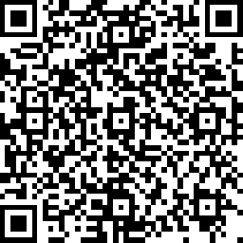

https://www.surveymonkey.com/r/2020DDV-SVSE-ENGLISH 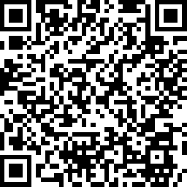

https://www.surveymonkey.com/r/2020DDV-LGLADV-ENGLISH 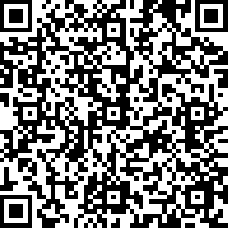

https://www.surveymonkey.com/r/2020DDV-LGLSER-ENGLISH 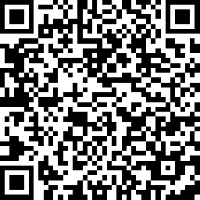

https://www.surveymonkey.com/r/2020-SVSE-Spanish 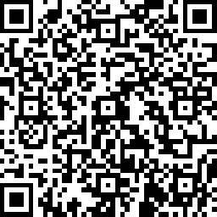

https://www.surveymonkey.com/r/2020-LS-Spanish 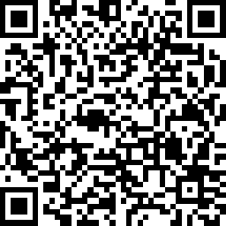

https://www.surveymonkey.com/r/2020-LA-Spanish 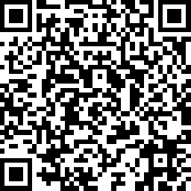

https://www.surveymonkey.com/r/2020-CO-Spanish 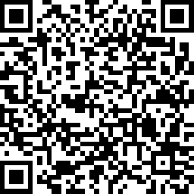

- The following surveys can be completed directly in Survey Monkey with the links provided above:

 | Counseling | Legal Advocacy | Legal Services | SVSE
English | X | X | X | X
Spanish | X | X | X | X

- QR codes have been created to access the following survey:

 | Counseling | Legal Advocacy | Legal Services | SVSE
English | X | X | X | X
Spanish | X | X | X | X

- Paper versions of the following surveys are posted on the City’s website along with 2021 Contract Documents:

 | Counseling | Legal Advocacy | Legal Services | SVSE
English | X | X | X | X
Spanish | X | X | X | X
Polish | X | X | X | X
Arabic | X | X | X | X

