
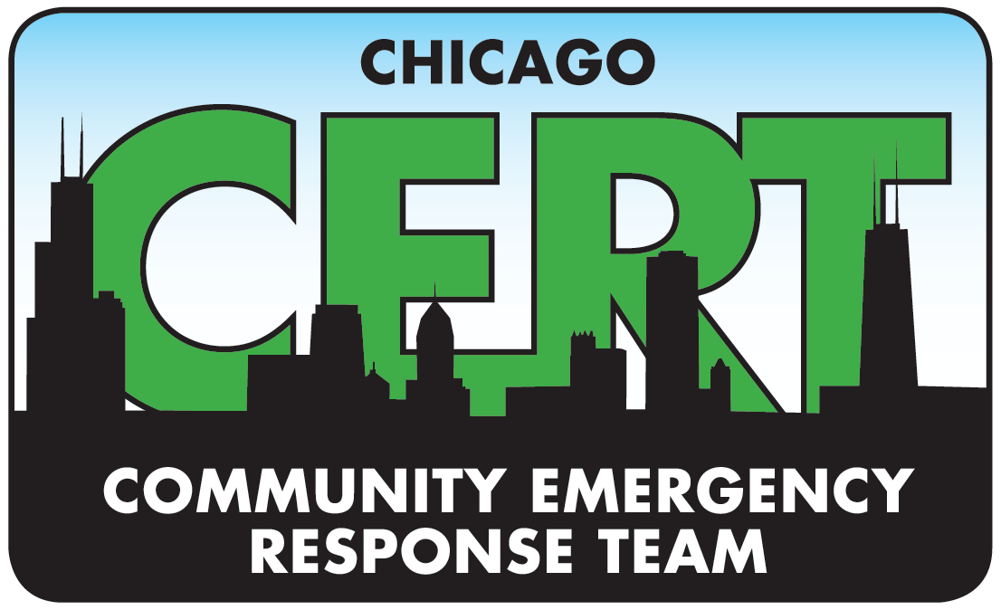

Chicago CERT Fall 2019 - Basic Training Class-Central

Course Objectives
CERT is a national community based educational opportunity for citizens to learn basic hands-on disaster response techniques that can be applied to daily lives. The CERT training also teaches citizens critical skills to support first responders when professional services are overwhelmed.

Course Agenda (Subject to change)
Location | Date/ Time | Topic
Chicago Police Dept. Academy  1300 W Jackson Blvd, Chicago, IL 60607 | September 10th  Tuesday  6:00pm-9:00pm | Introduction & Orientation  Unit 1: Disaster Preparedness
Chicago Police Dept. Academy  1300 W Jackson Blvd, Chicago, IL 60607 | September 12th  Thursday  6:00pm-9:00pm | Unit 1: Disaster Preparedness  Unit 6: CERT Organization
Chicago Police Dept. Academy  1300 W Jackson Blvd, Chicago, IL 60607 | September 17th  Tuesday  6:00pm-9:00pm | Unit 2: Fire Safety & Utility Controls
Chicago Police Dept. Academy  1300 W Jackson Blvd, Chicago, IL 60607 | September 19th  Thursday  6:00pm-9:00pm | Unit 7: Disaster Psychology  Unit 8: Terrorism & CERT
Chicago Police Dept. Academy  1300 W Jackson Blvd, Chicago, IL 60607 | September 24th  Tuesday  6:00pm-9:00pm | Unit 3: Medical Operations
Chicago Police Dept. Academy  1300 W Jackson Blvd, Chicago, IL 60607 | September 26th  Thursday  6:00pm-9:00pm | Unit 4: Medical Operations
Chicago Police Dept. Academy  1300 W Jackson Blvd, Chicago, IL 60607 | October 1st  Tuesday  6:00pm-9:00pm | Unit 5: Light Search & Rescue Operations
Location to be determined | October 3rd  Thursday  6:00pm-9:00pm | Unit 9: Final Exam and Exercise
Chicago Police Dept. Academy  1300 W Jackson Blvd, Chicago, IL 60607 | October 8th  Tuesday  6:00pm-9:00pm | ****CHICAGO CERT Advanced Training ****

Lead Chicago CERT Instructor: Director, Rich Frizelis

*If you cannot complete any part of the course due to scheduling conflicts or otherwise, please contact Chicago CERT Director – Rich Frizelis 773-255-3882, or richf.chicagocert@gmail.com

** Upon receiving the participant manual, participants are advised to review relevant portions prior to the start of each class

Course Certification Requirements
- Participants must satisfactorily complete all 24 hours of instruction, the final exam, and simulated exercise.

Fall 2019

