
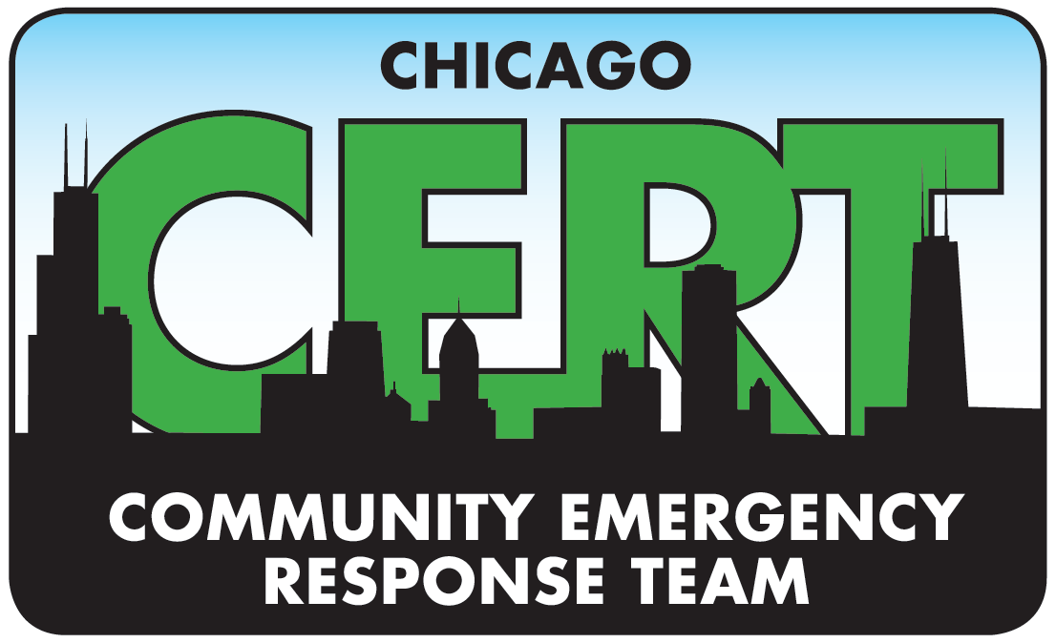

Chicago CERT Fall 2019 - Basic Training Class

Course Objectives
CERT is a national community based educational opportunity for citizens to learn basic hands-on disaster response techniques that can be applied to daily lives. The CERT training also teaches citizens critical skills to support first responders when professional services are overwhelmed.

Course Agenda (Subject to change)
Location | Date/ Time | Topic
Location to be determined | September 10th  Tuesday  6:00pm-9:00pm | Introduction & Orientation  Unit 1: Disaster Preparedness
Location to be determined | September 12th  Thursday  6:00pm-9:00pm | Unit 1: Disaster Preparedness  Unit 6: CERT Organization
Location to be determined | September 17th  Tuesday  6:00pm-9:00pm | Unit 2: Fire Safety & Utility Controls
Location to be determined | September 19th  Thursday  6:00pm-9:00pm | Unit 7: Disaster Psychology  Unit 8: Terrorism & CERT
Location to be determined | September 24th  Tuesday  6:00pm-9:00pm | Unit 3: Medical Operations
Location to be determined | September 26th  Thursday  6:00pm-9:00pm | Unit 4: Medical Operations
Location to be determined | October 1st  Tuesday  6:00pm-9:00pm | Unit 5: Light Search & Rescue Operations
Location to be determined | October 3rd  Thursday  6:00pm-9:00pm | Unit 9: Final Exam and Exercise
Location to be determined | October 8th  Tuesday  6:00pm-9:00pm | ****CHICAGO CERT Advanced Training ****

Lead Chicago CERT Instructor: Director, Rich Frizelis; CPD Instructor: Sergeant Chris Schenk

** Upon receiving the participant manual, participants are advised to review relevant portions prior to the start of each class

Course Certification Requirements

- Participants must satisfactorily complete all 24 hours of instruction, the final exam, and simulated exercise.

Fall 2019

